**Learning, Teaching and Assessment in John Logie Baird Primary School**

**Updated January 2025**

At John Logie Baird Primary School our Learning Teaching and Assessment Policy is underpinned by “How Good is Our School” indicators shown below. Our aim for all pupils is for them to each fulfil their own unique potential and offer opportunities for rich learning experiences which engage and help develop skills for life, learning and work. We further aim to develop the outcomes detailed for pupils in our education authority vision and strategy – “Our Children, Their Future”.

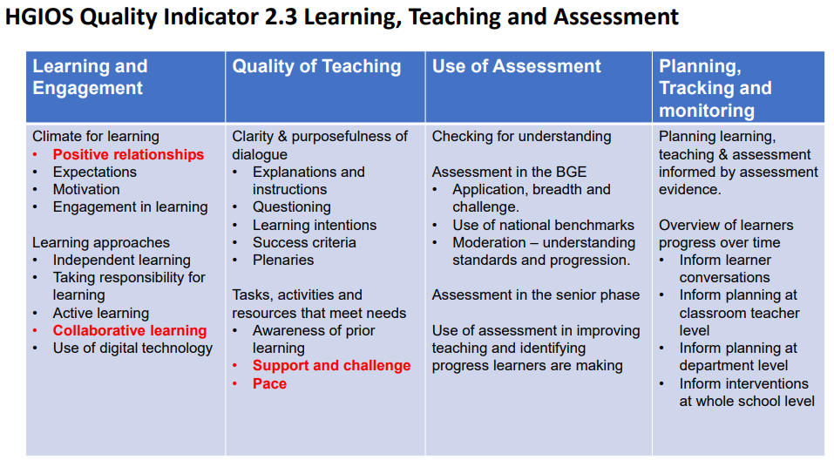

Furthermore we take cognisance of Quality Indicator 3.1 when considering all our learners:

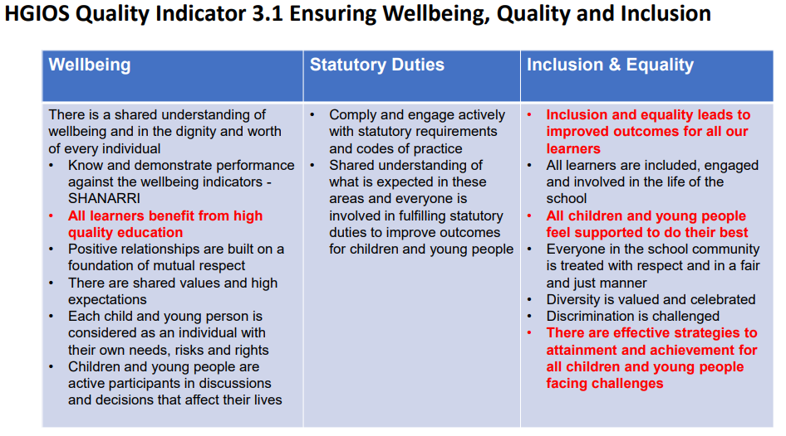

**Introduction**

At our core we share the following beliefs about teaching, learning and assessment:

* Children should not just learn but develop the attributes that allow them to be great learners and thinkers.
* All children have the opportunity to access and master all learning; it is our job to ensure that all children are enabled to do this.
* Children should not just attain against CFE objectives but should achieve through deep learning experiences.
* Our rich curriculum should be delivered through carefully crafted programmes of learning.
* Individual lessons are precisely structured in order to create learning, not deliver teaching.
* Our classroom practice is based on sound pedagogy and the belief that children learn best through collaboration and enquiry.
* Assessment in all its forms is at the heart of teaching and learning; it gives direction and impact to what we do.

**The Learner**

We have identified the key school values that we promote in our school. By focusing on these values , across a broad and balanced curriculum, our children develop the skills and capabilities to become effective life-long learners.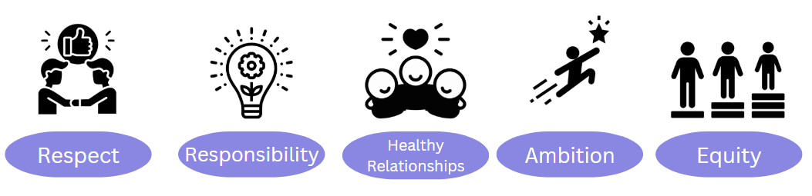

**Skills for Life, Learning and Work:**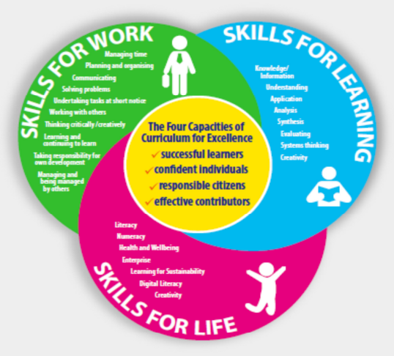

**Leading to:** 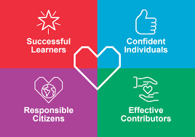

**Our Inner Curriculum**

A full curriculum is not complete unless school essentials are established. Our school essentials, context, values, community vision and aims define the content of our school curriculum. In making these the drivers of our curriculum, we shape the CFE around the needs and context of our school. Using contributions from staff, parents, children and partners we have identified important aspects of our context which should be considered and included in our curriculum:

**Our Curriculum Rationale**

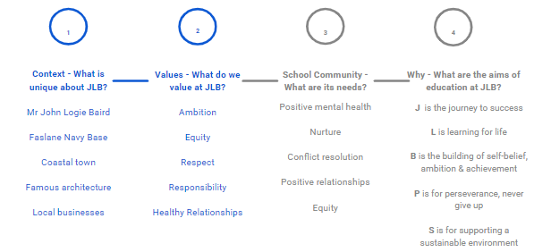

**Our Approach to Learning**

Our approach to learning aims to give all the pupils opportunities to accomplish the following within their learning:

**Greater Depth**

**Engagement**

**Higher Order Skills**

We use our curriculum and supporting frameworks to provide a consistent approach to learning across year groups in the school. Our whole school curriculum provides a basis and ideas but should be responsive and adapted to be current, relevant and to take into account the interests of the group of learners being taught.

We support our pupils in developing 21st Century skills through embedding skills for life, learning and work. 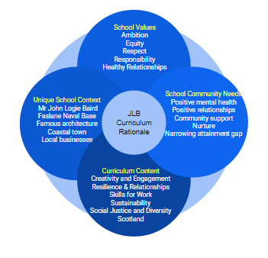

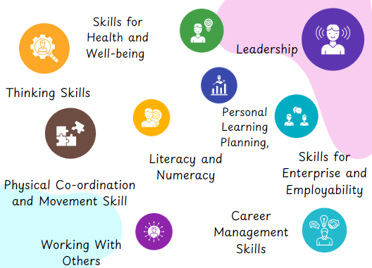

**The Teacher**

We have staff who create learning environments built on positive, nurturing and appropriately challenging relationships which lead to quality learning outcomes. Staff collaborate to access and apply relevant findings from educational research and professional reading to improve learning and teaching. Improvement is also driven by data literate staff who scrutinise data to increase the rate of progress for learners and close the poverty related attainment gap. Depth, breadth, challenge and application are developed across a curriculum which allows individual learning pathways to be tailored to the needs and context of the learners.

Engaging in professional dialogue and collaboration is essential and opportunities for dialogue are created throughout the school year focusing on:

∙ The annual PRD cycle

∙ Attainment meetings to discuss learning across all classes

∙ Partnership working with HALCO schools

∙ Staff meetings and INSETs

Achievable and accessible targets for Literacy and Numeracy are created and evaluated in learning conversations between learners and their teacher. Targets are personalised to match individual needs and opportunities to celebrate success with peers and families are provided throughout the school year.

A positive classroom ethos is created in classrooms in which confidence and success is built and mistakes are encouraged and celebrated as a way of building learners' confidence and encouraging barriers to be broken down.

**A Quality Lesson**

Across John Logie Baird Primary school we aim to have a consistent approach to planning the structure of our lessons to ensure that quality teaching and learning takes place. We have developed a curriculum and programmes of study to ensure the progression of learning across all subjects. Lessons are planned to ensure all children can achieve the knowledge, skills and understanding required and that any ceiling to learning is removed.

We continually adapt our planning to respond to the needs of all learners through many support mechanisms, some of these include:

* Differentiation of task to suit learner ability
* Learning scaffolded by teacher
* Learning Support Teachers
* Nurture Teacher
* Peer Support
* Nurturing Classroom Environments
* Wide variety of practical resources
* Support Staff in classes
* English as an Additional Language Teacher
* Staged Intervention Processes
* GIRFEC
* Other External Agencies Support

Planning needs to be responsive to the children’s learning and continually adapted based on the ongoing assessment of children’s knowledge, skills and understanding. When planning learning it is useful to consider the structure that takes place within one lesson. Teaching and learning are not the same thing. Encountering information is not the same as understanding it. While the stages are inextricably linked, they are separate processes. This must be reflected in the lesson.

**Introduction:**

* Work from the previous lesson is reviewed.
* Link to prior learning is made
* Lesson is placed in a wider context- students are provided with an overview.
* Specific Learning Intentions are shared with learners.
* Targets – collective and individual – are set by the teacher and generated by learners.

**Development :**

* Information is presented in short chunks.
* Teacher talk time is kept brief and does not exceed learners’ concentration span.
* Teacher frequently ask a mixture of open and closed questions to check for understanding.
* New information is delivered in a variety of ways, to suit students with visual, auditory and kinaesthetic learning preferences
* Teacher checks that all learners understand technical language and subject-specific terms.
* Frequent teacher-learner and peer interactions.
* Time allowed for learners to think about and discuss their responses to questions.
* Questions that encourage learners to reflect on their thinking.
* Opportunities for learners to generate questions.
* Learners fully engaged in their lessons.
* Tasks develop understanding and opportunities are given for pupils to demonstrate their understanding.
* Tasks enable teacher to assess understanding.
* An emphasis is put on encouraging pupils to work independently.

**Conclusion:**

* Sufficient time devoted to reviewing what has been learned.
* Learners actively engaged in the review process.
* Explicit reference to Learning Intentions. Learners encouraged to reflect on how they have learned

**Pedagogical strategies**

John Logie Baird Primary teachers use a range of pedagogical strategies to ensure high quality teaching, learning and assessment is taking place within each phase, at every stage. We know learning takes place when teachers make appropriate and precise decisions about the teaching strategies they use some examples are:

* Talking Listening Learning
* Cooperative learning
* Active Learning
* Encouraging children to lead the learning

**Feedback and Assessment**

Assessment and Feedback are key drivers within the Learning, Teaching and Assessment Cycle. Moderation should be ongoing and occur before, during and after the planning of learning, teaching and assessment. Below is the Education Scotland Learning, Teaching and Assessment Cycle (formally Moderation Cycle) which forms the basis of planning learning, teaching and assessment in our school.

**Marking and Feedback**

A small number of basic principles underpin our approach to marking and feedback:

1. Teachers must use pupils’ recorded work to assess understanding and address pupil misconceptions as part of the teaching cycle.

2. All work should be acknowledged however, this might be by the teacher or through peer or self-assessment.

3. Peer and self-assessment are powerful tools and pupils should be guided in their appropriate use. Pupils should also be encouraged to reflect on their own learning.

4. Marking should be proportionate and often verbal feedback will be given in place of this when working in small groups or with our younger learners. The important point is that children receive feedback on their work and advice on how to progress with next steps.

**The Assessment of Learning**

Our approach to assessment aims to:

* Ensure no learning is left behind.
* Enable all children to know their strengths and areas for development.
* Ensure that children progress in and across lessons.
* Ensure that in planning learning lessons are amended to ensure that teaching and learning is responsive to the needs of all children.
* Gather information about the progress and attainment of individual pupils, groups and cohorts, which is used to set specific targets, and identify strengths and areas for development in learning.
* Inform parents of their children’s progress on a regular basis.
* Monitor and record the attainment and progress of individuals, groups and cohorts.
* Support teachers in their continuing review of learning on a consistent basis in order to identify gaps and misconceptions.

**The Three Aspects of Assessment**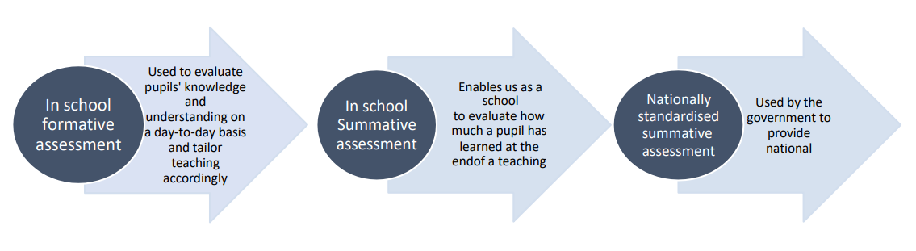

**Assessment is for Learning**

In John Logie Baird Primary School formative assessment is used to evaluate pupils’ knowledge and understanding on a day-to-day basis and to tailor teaching accordingly.

Formative assessment is used to assess knowledge, skills and understanding, and to identify gaps and misconceptions. A range of methods are used to evaluate pupil understanding and enable teachers to be responsive to the needs of the pupils. These include:

* Learning Intentions
* Success Criteria ( co-created with children)
* Peer Assessment
* Self Assessment
* Questioning
* Traffic Lights
* 2 Stars and a Wish
* Me - You - We
* Round robin Marking
* C3 B4 Me
* Feedback
* High Quality Assessments

Pupils across our school play a pivotal role in the assessment process, providing a useful insight into their own understanding through peer and self-assessment processes. The model for assessment ensures pupils with ASN are assessed appropriately and effectively in line with the purposes and principles of inclusive assessment.

**In-School Summative Assessment**

* In school summative assessment enables our school to evaluate how much a pupil has learned at the end of a teaching period.
* All summative data is used by teachers as part of the Learning, Teaching and Assessment cycle.
* Summative assessment is targeted and appropriate for informing our teaching and learning.
* Standardised commercial tests used within school have been validated and are administered in line with test protocols. The information provided is then used by teachers to feed into next steps for children. This is done as part of a moderation process and is well grounded, ethical and supportive of our approaches to teaching and learning.

**National Standardised Assessments**

National standardised summative assessment is used by the government.

At the end of P1, 4 and 7 will be assessed in reading, writing, maths. They will be given a scaled score and a ‘performance descriptor’ against the expected standard. The results from these tests are used by teachers as a diagnostic tool for future planning.

Our approach to teaching, learning and assessment is designed to ensure all children leave our schools with the attributes and capabilities to be life-long learners. At John Logie Baird Primary we believe that improved outcomes equate to improved life chances for our pupils.

**Tracking attainment and progress**

The way that we track progress and attainment ensures that we have a comprehensive online tracking tool for attainment throughout all curricular areas and wider achievements. We recognise pupils make small steps towards each outcome throughout the year and that learning does not take place in convenient termly ‘chunks’. We, therefore, formally record the outcomes for pupils at checkpoints which are identified in the yearly quality assurance planner, collegiate planner and encompass the dates for the Argyll and Bute XBRA data uplift.

*At John Logie Baird Primary School we fully endorse the Argyll and Bute Learning, Teaching and Assessment Framework.*

**This policy upholds the following articles of the UNCRC:**

* The right to ‘protection against discrimination’ (Article 2)
* The right to have adults to do what is best for them
* The right ‘to be given proper care by those looking after them’ (Article 19)
* The right ‘to contribute meaningfully to the decisions and circumstances that affect their lives’(Article 19)
* The right to an education that prepares them for responsible life in a free society. (Article 29)
* The right to take part in cultural and creative activities (Article31)